

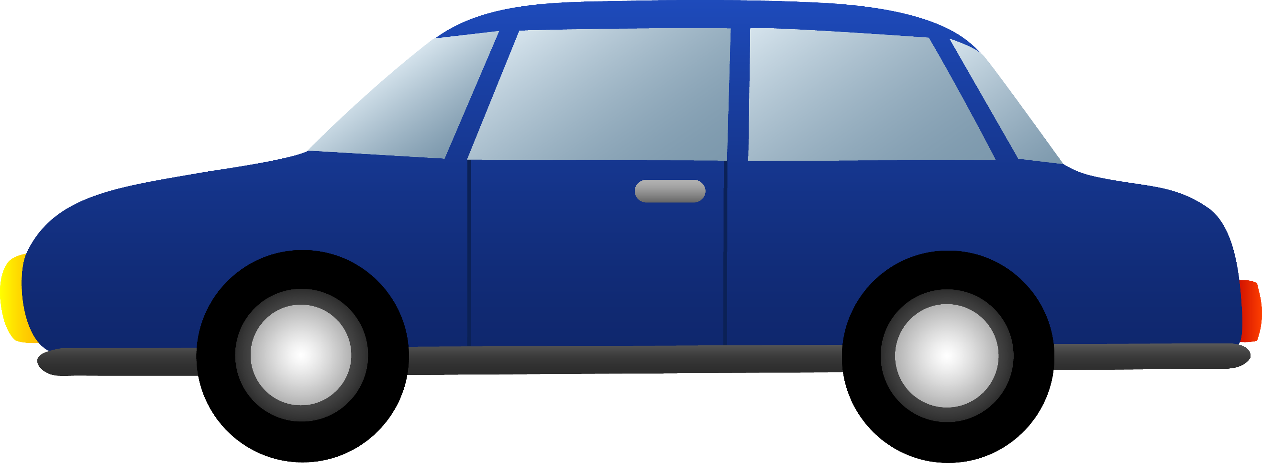Hillbrow
Kempton Park
 Sandton
Rosenttenville
Kensington
Braamfontein
 Town
 Yeoville

BEREA

